**Story of an organization and Problem introduction**

* Organization name: Contoso
* Application: ecommerce
* Architecture:  
  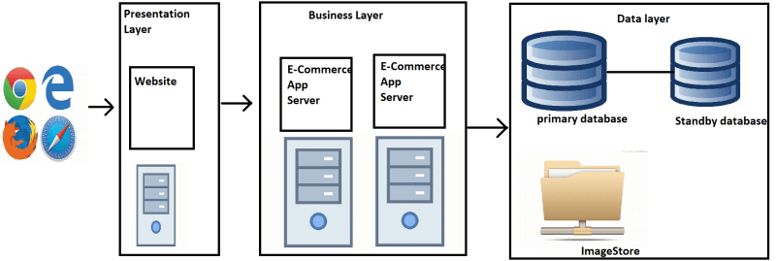
* Problems:
  + Different front-ends (iOS, Android)
    - Accessibility
    - Cross platform

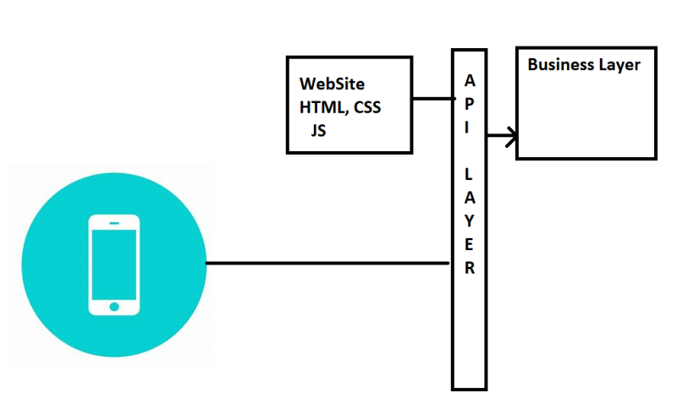

Deployment of new features:

* + - typically, are having more downtimes
    - Zero Down time Deployments
    - Faster Deployments

Contoso wants to run this application on any cloud or on-premises.

* + - Portability

De Composing application into smaller services according the business needs  
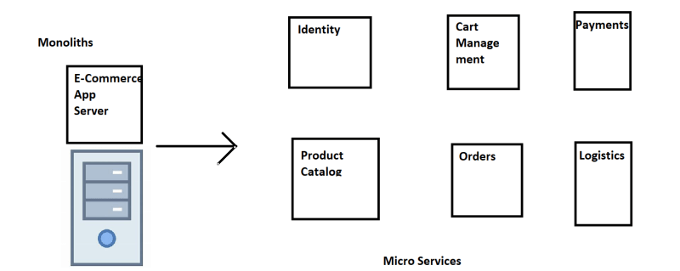

* + Updating any microservice can be done independently
  + Re using microservices is much easier.
  + Scaling for microservice is much easier and cheaper compared to Scaling monolith.

Solution:

* + Container technology (Docker)
  + Container Orchestration (Kubernetes)

Monolithic to Microservice Deployment comparisons:

Containers are move towards uniform process.

